AI ASSISTED CODING
LAB TEST-04

NAME : Devasani Meenakshi
BATCH : 03
ROLL NO : 2403A52051
Set : 12

Question 1: (API Integration)
- Fetch NASA Astronomy Picture of the Day via API.
- Handle missing image or metadata

Prompt:
Write a Python function fetch_apod(api_key=None, save_image=True, dest='apod.jpg') that calls NASA's APOD API, returns a dict containing the metadata, saves the image if present, and gracefully handles cases where the APOD is a video or metadata fields are missing. Use requests, timeouts, and clear error handling.
Code And Output:
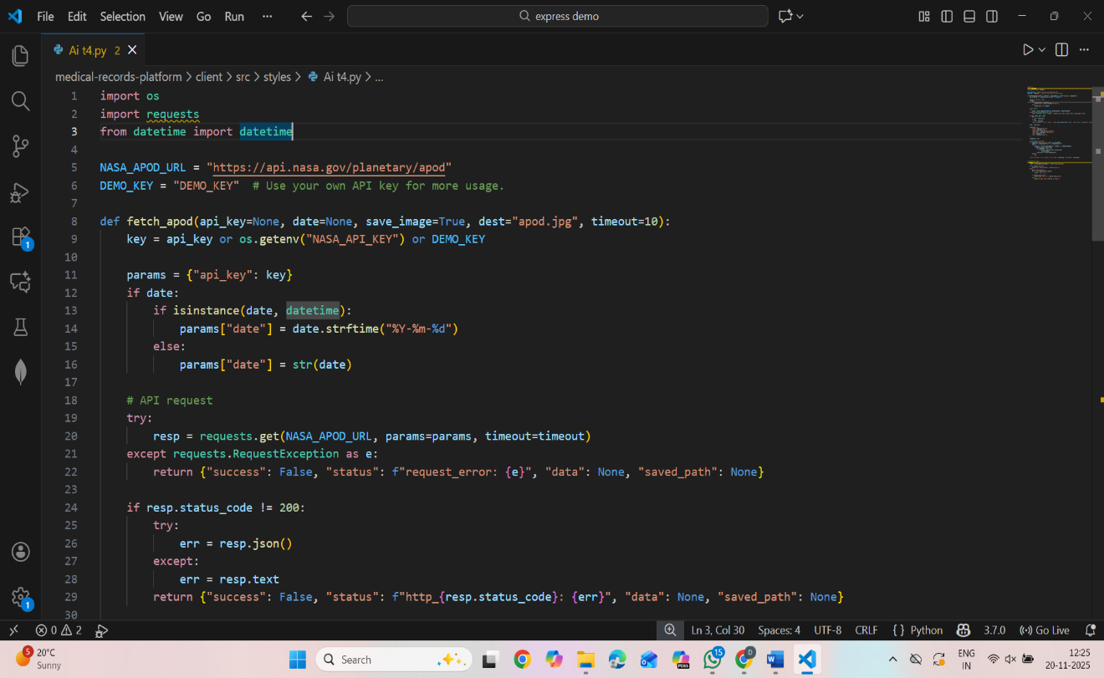
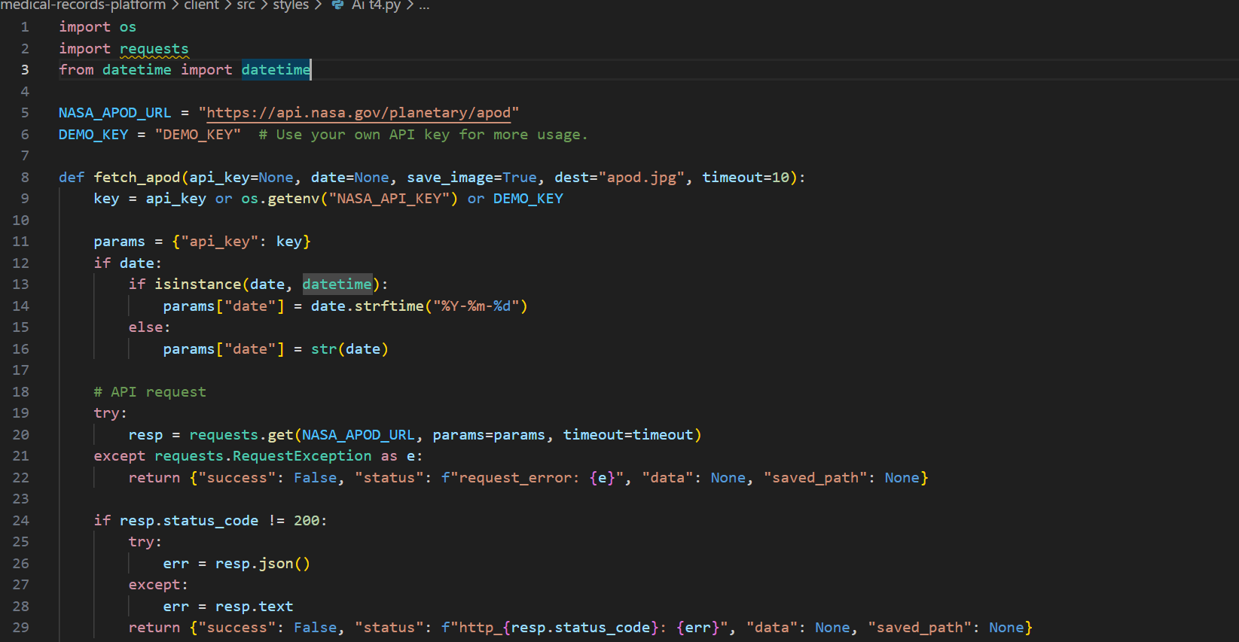
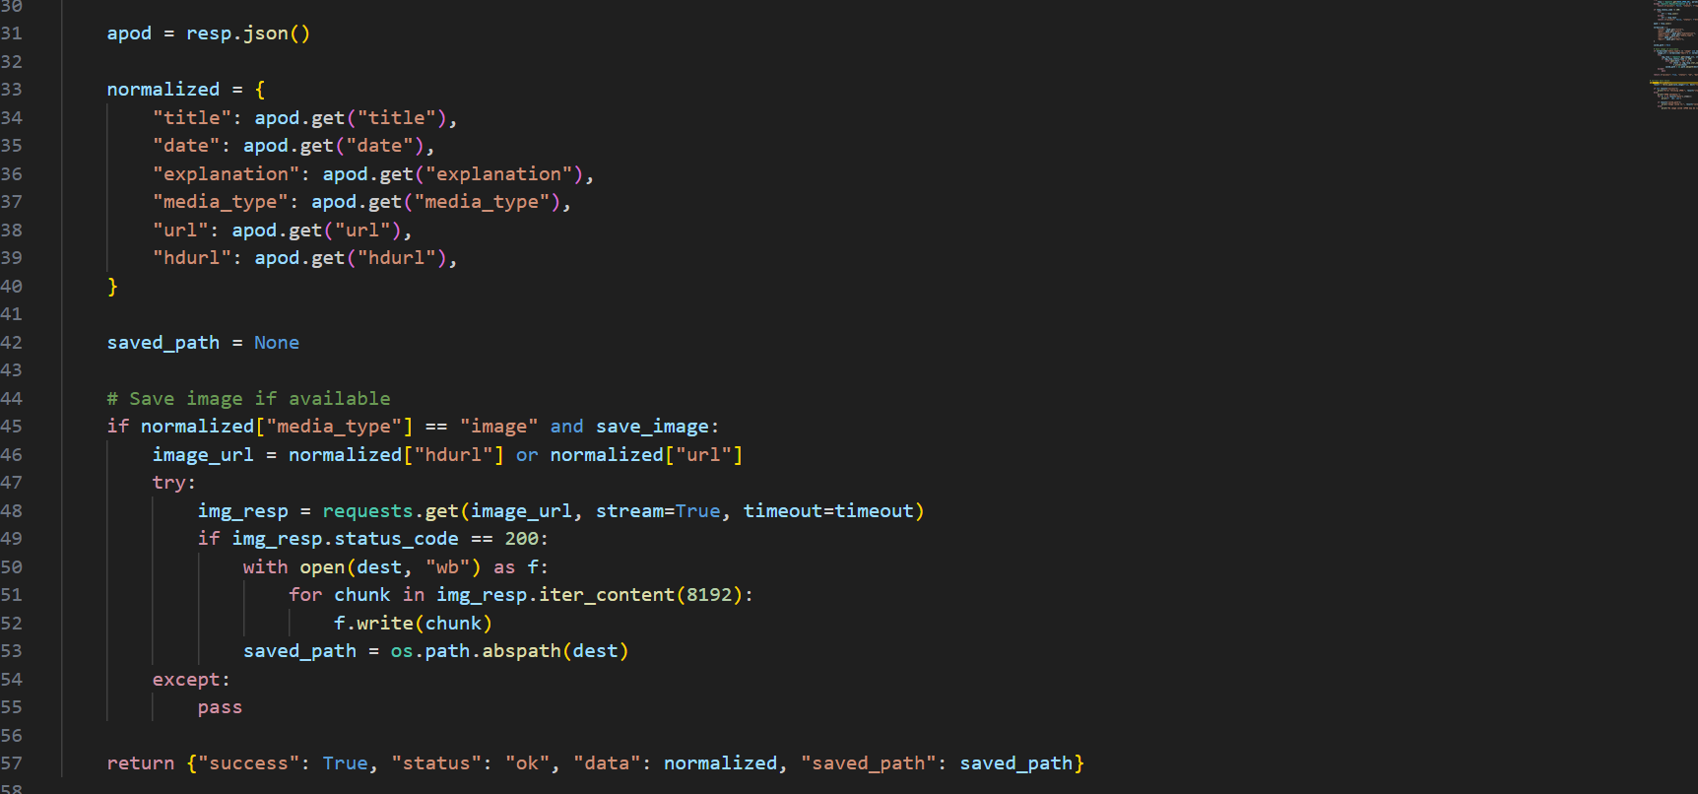
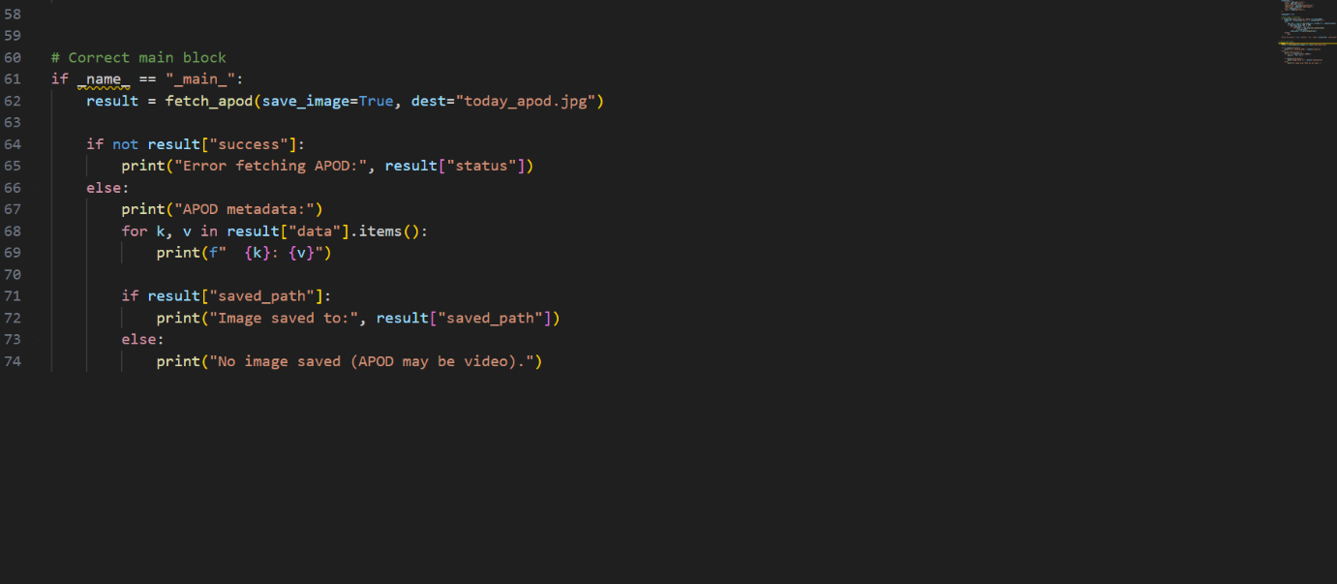
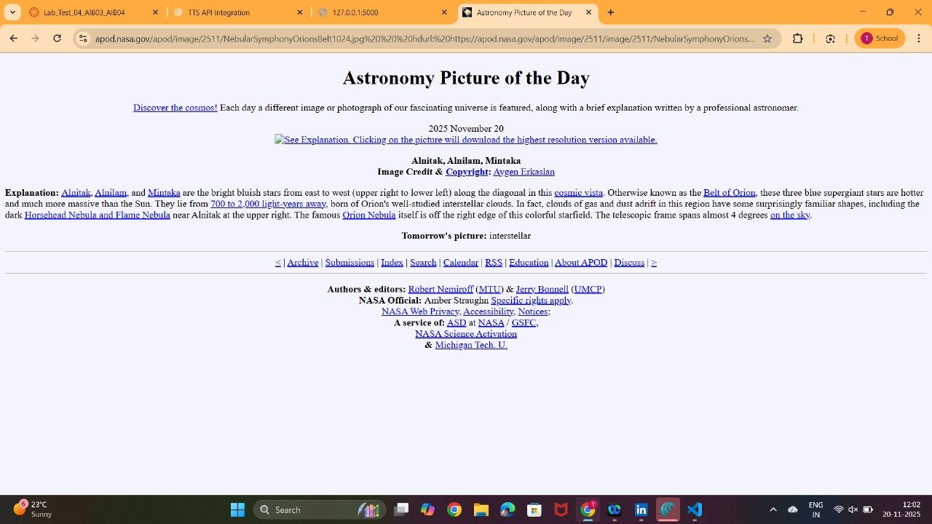
Explanation:
The function calls https://api.nasa.gov/planetary/apod with an API key (uses NASA_API_KEY env var or DEMO_KEY fallback).

It safely handles network errors and non-200 responses and returns a structured dict (success, status, data, saved_path).

data is normalized so missing fields are None rather than raising errors.

If media_type == "image", it attempts to download hdurl (preferred) or url and saves to dest. If APOD is a video (common), it doesn't try to save an image and includes a note.

Using the DEMO_KEY works for examples but is rate-limited; for production get a personal API key from https://api.nasa.gov
Q2. (Code Translation)
a) Translate a Rust function to Python.
b) Discuss performance differences.

Prompt:
Translate this Rust function (Sieve of Eratosthenes) to Python: produce idiomatic, readable Python that returns a list of primes ≤ n. Include error handling and a small benchmark snippet. Keep the translation simple and efficient.
CODE & OUTPUT:

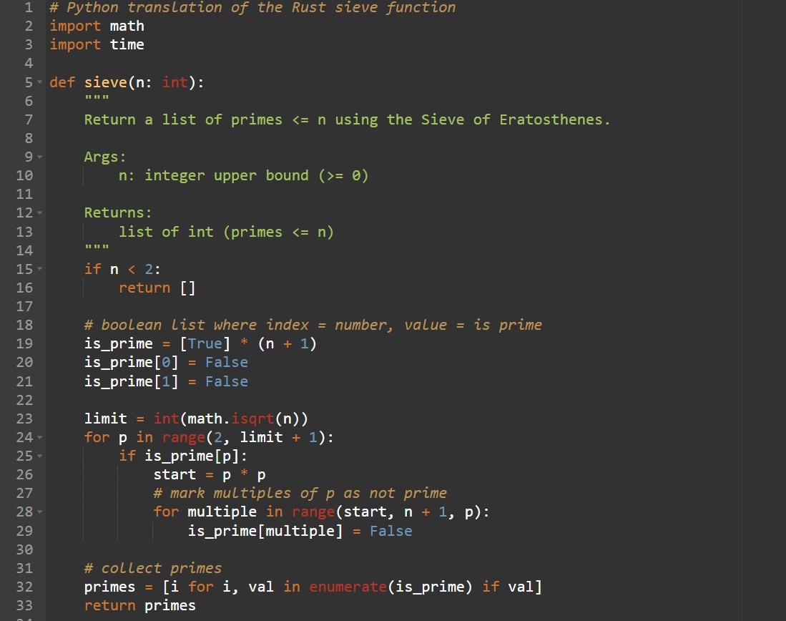

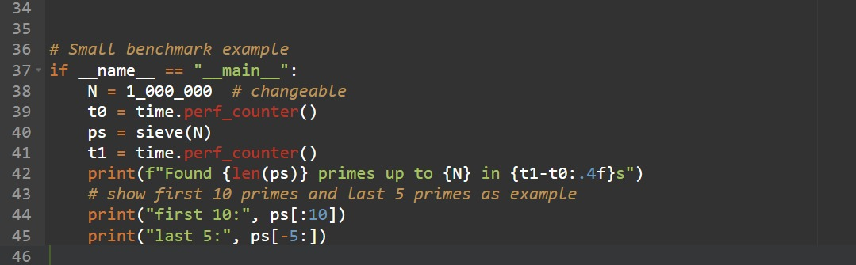
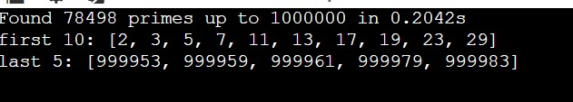

EXPLANATION:
Rust is faster because it compiles to optimized machine code, has no interpreter overhead, and handles memory more efficiently. Python is slower due to its interpreter, object-based booleans, and higher loop overhead. Both use the same sieve algorithm, but Python typically runs many times slower. You can speed Python up using bytearray, numpy, or C/Rust extensions.

